**Assignment – Finding Efficiencies:**

After creating the sheets for Sales, Profit and Discount with year and using the products, we observed there is a dip in Profit from the year 2018. The profit in year 2018 is 79.183 whereas in 2019 is 77,712.

**With category filtered with Furniture:**

Bookcases and Tables caused loss because of the discount that has been incremented from 2018 to 2019.

**Bookcases:**

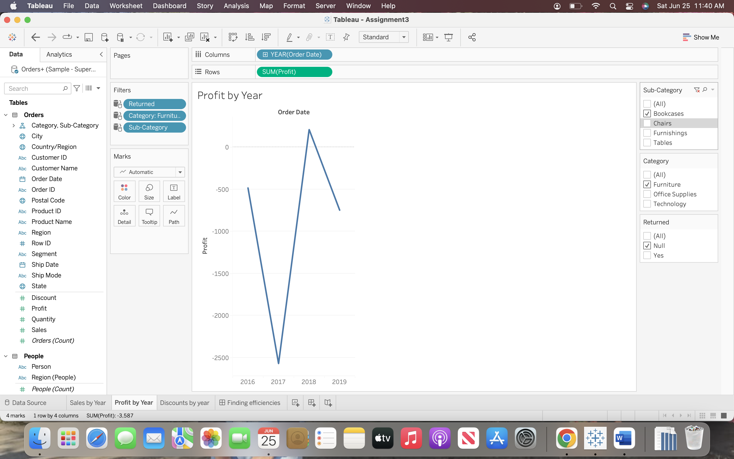

**Tables:**

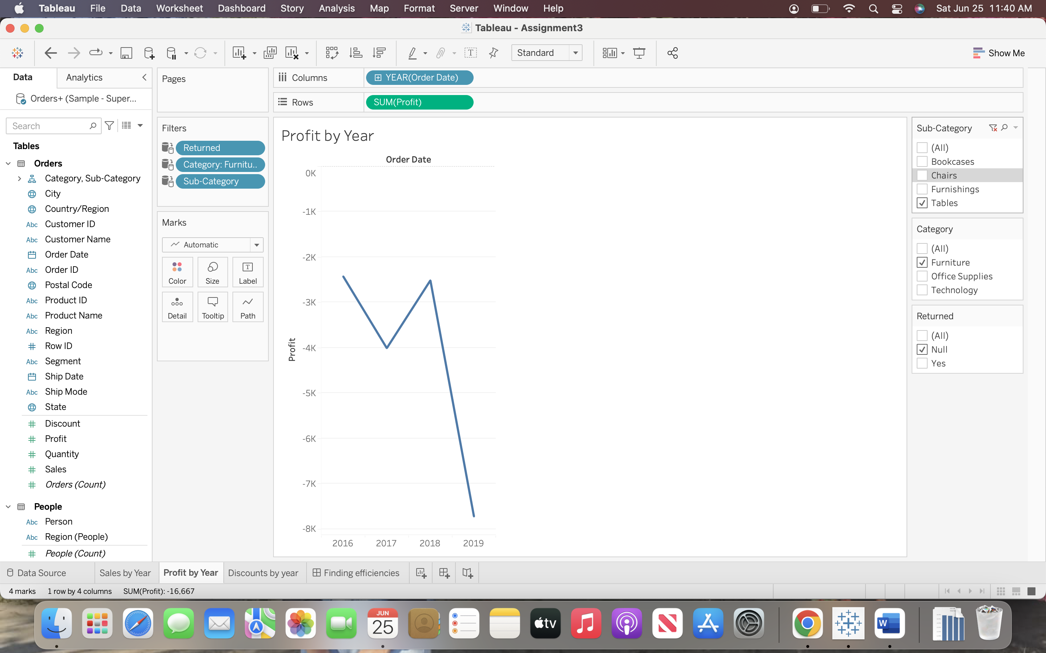

**With category filtered with Office supplies:**

Binders, Envelopes, Fasteners, Supplies caused loss because of the discount that has been incremented from 2018 to 2019.

**Binders:  
  
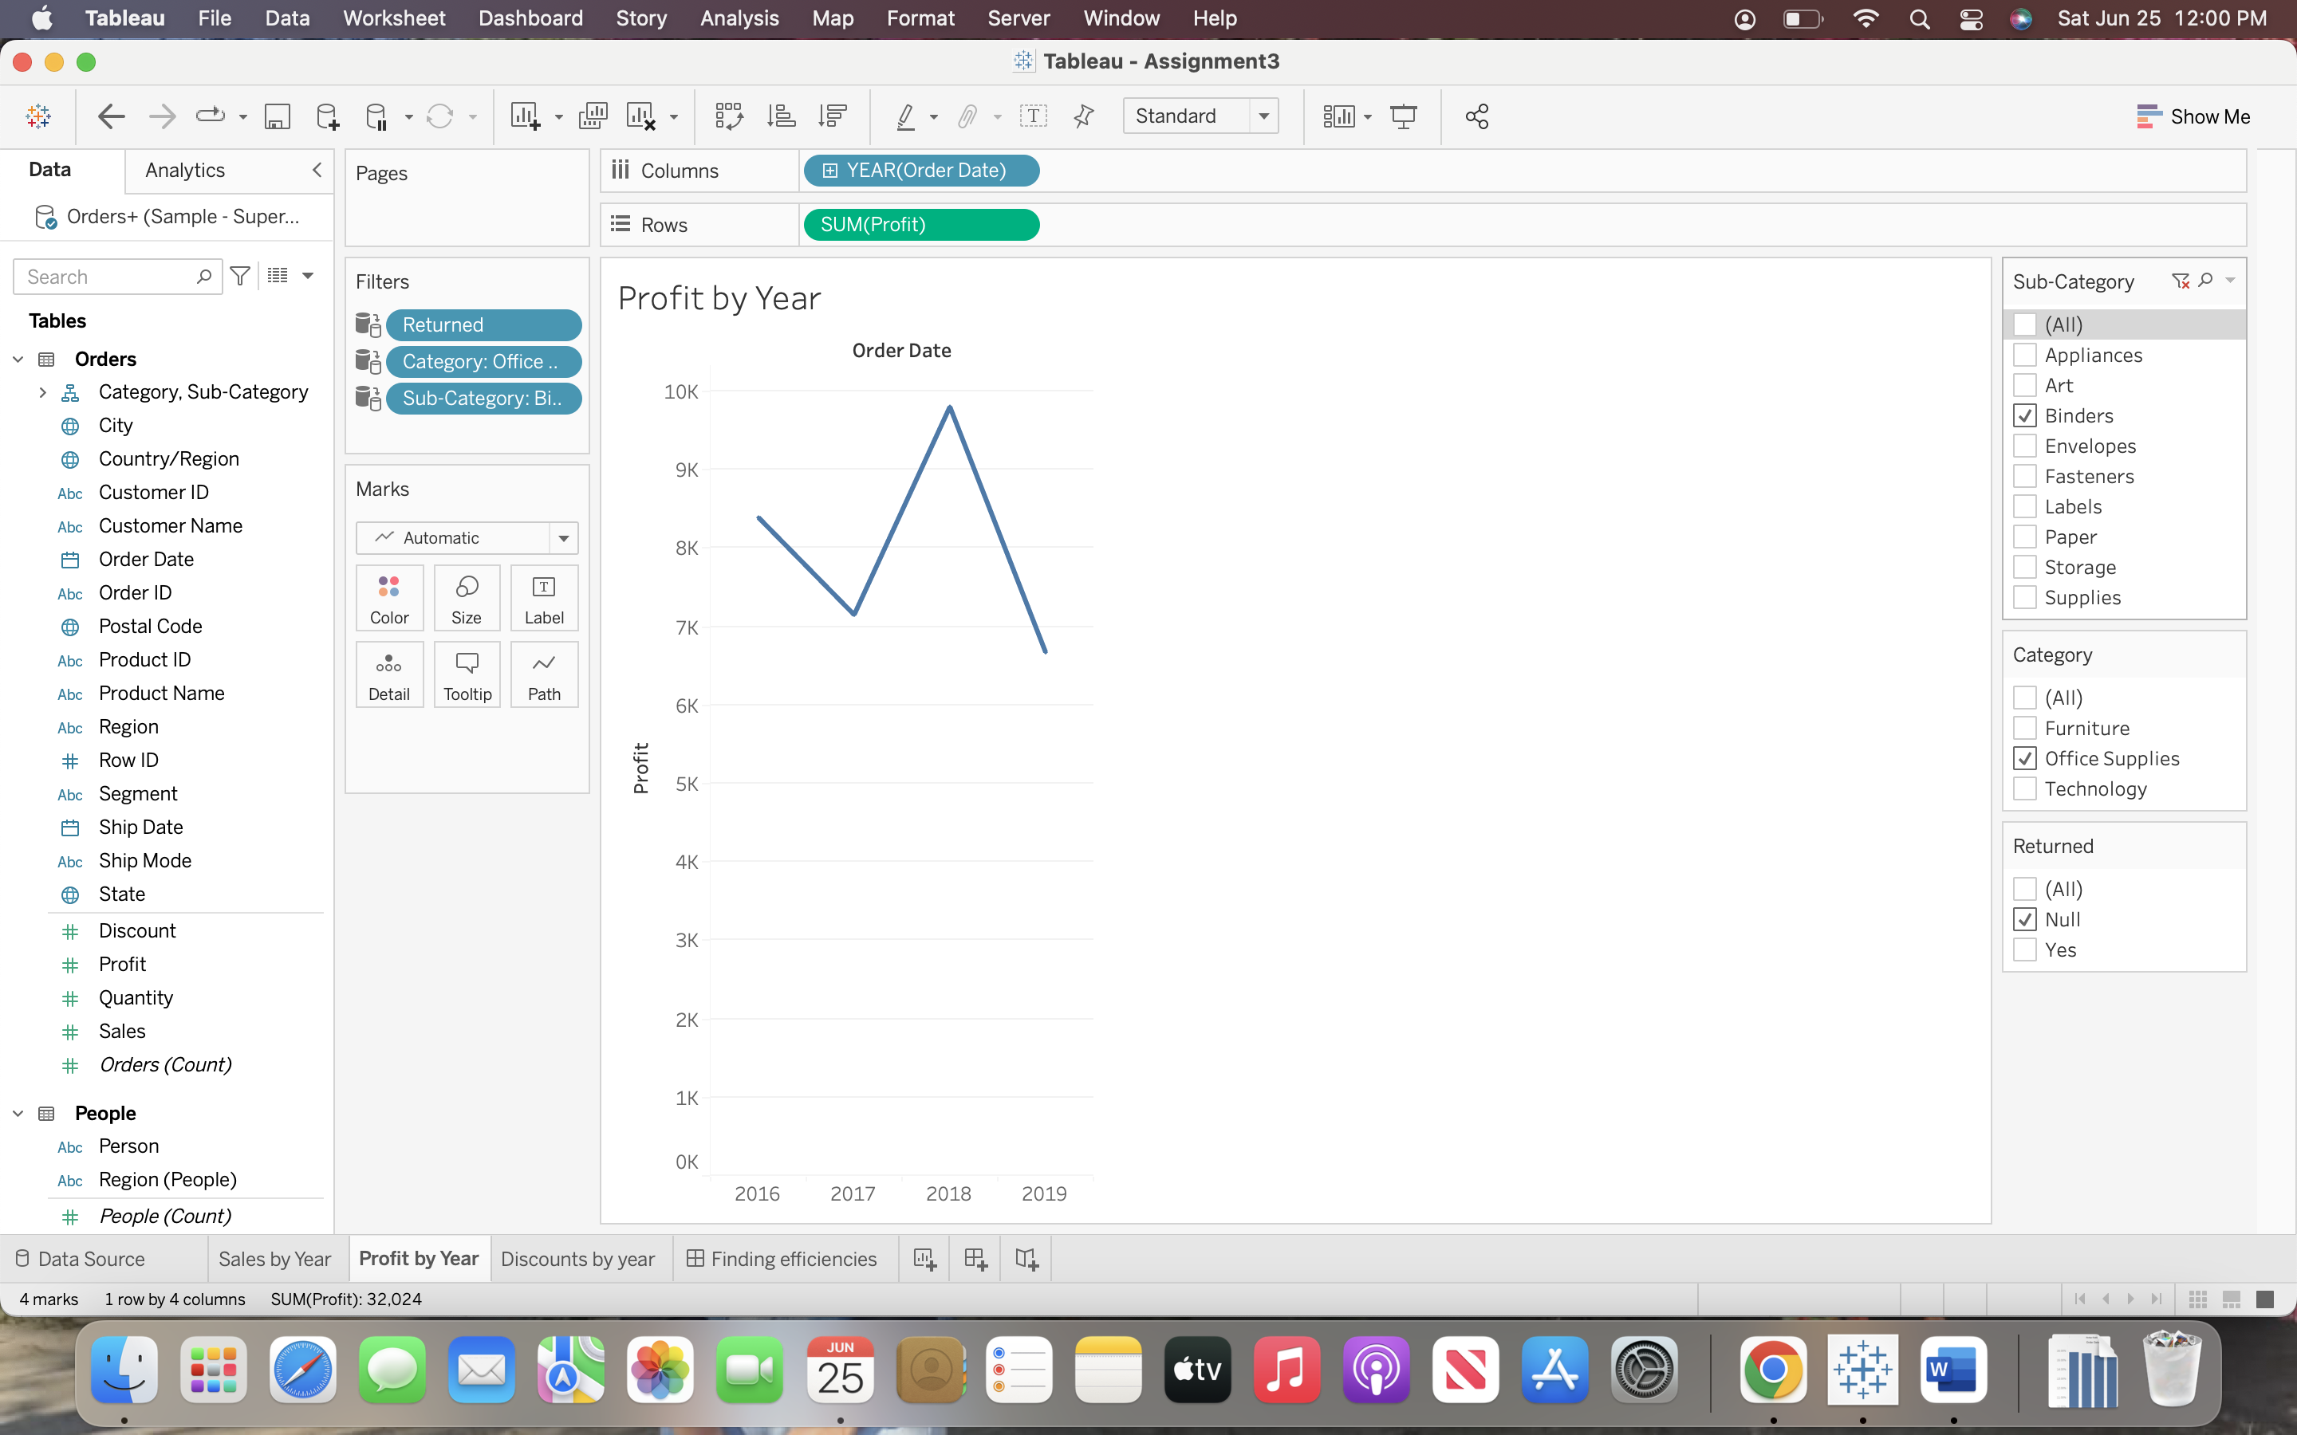**

**Envelopes:  
  
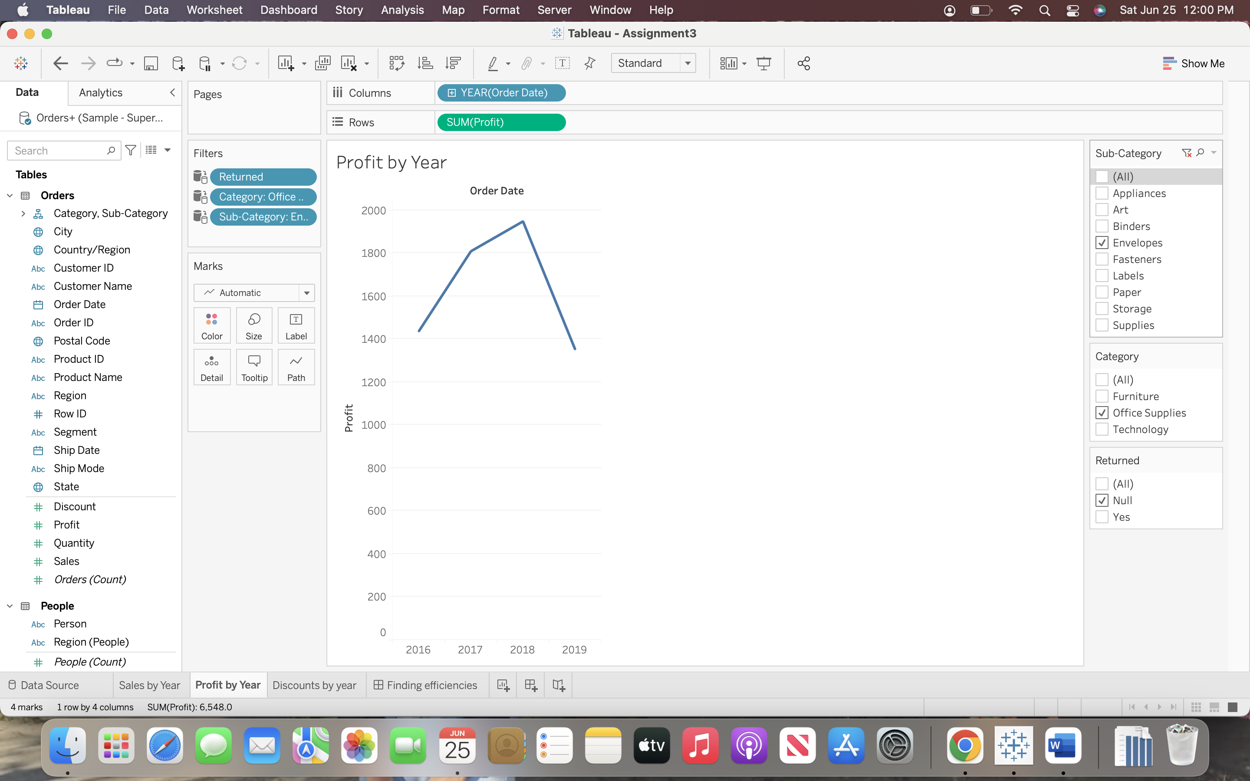**

**Fasteners:  
  
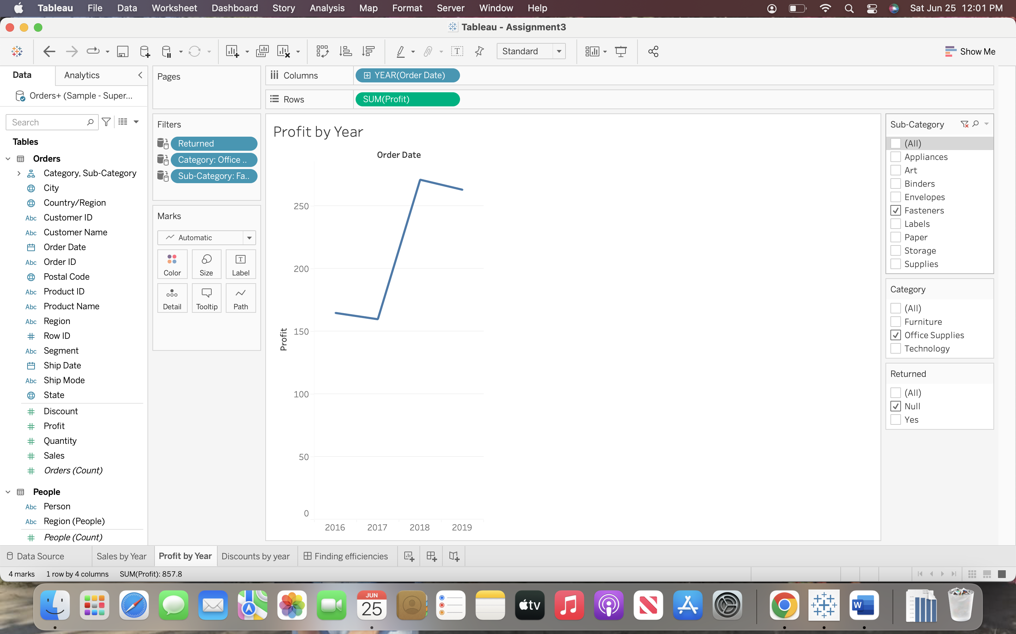**

**Supplies:**

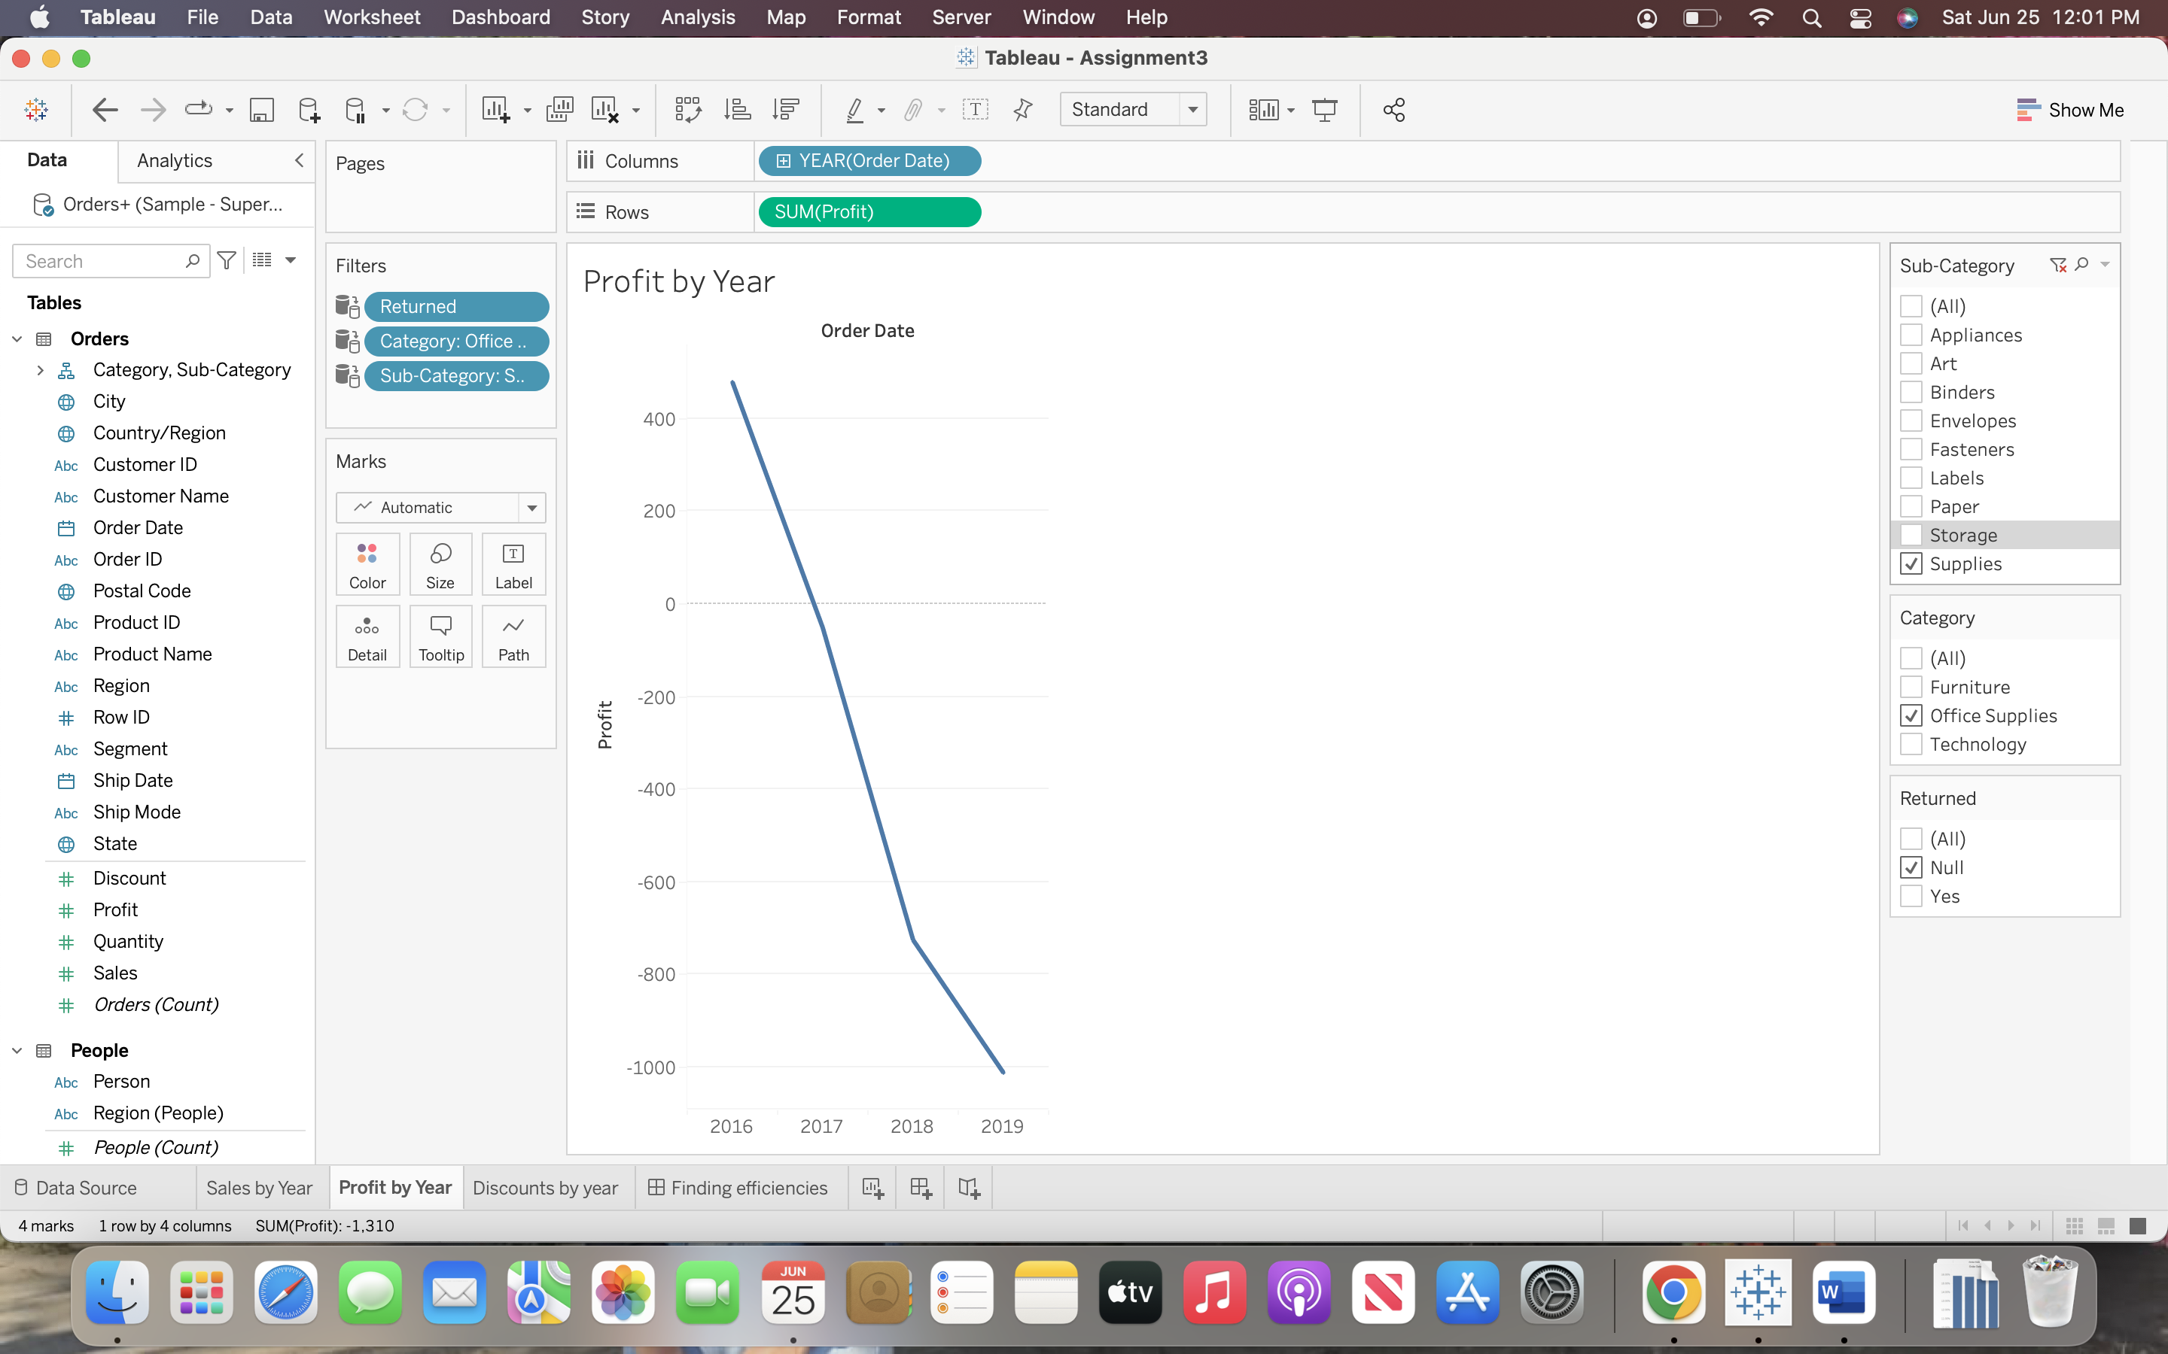

**With category filtered with Technology:**

Machines caused loss because of the discount that has been incremented from 2018 to 2019.

**Machines:**

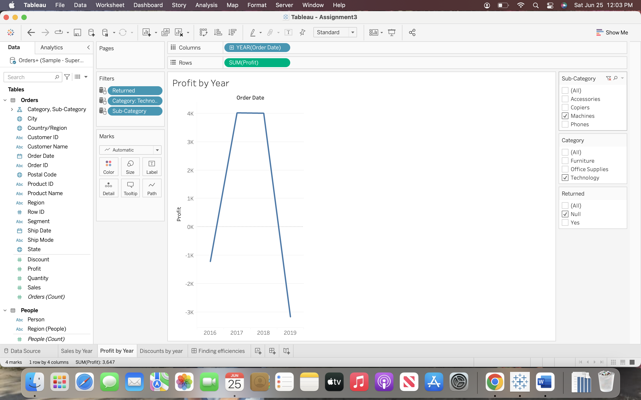

Overall Furniture has caused more loss due to the discounts.

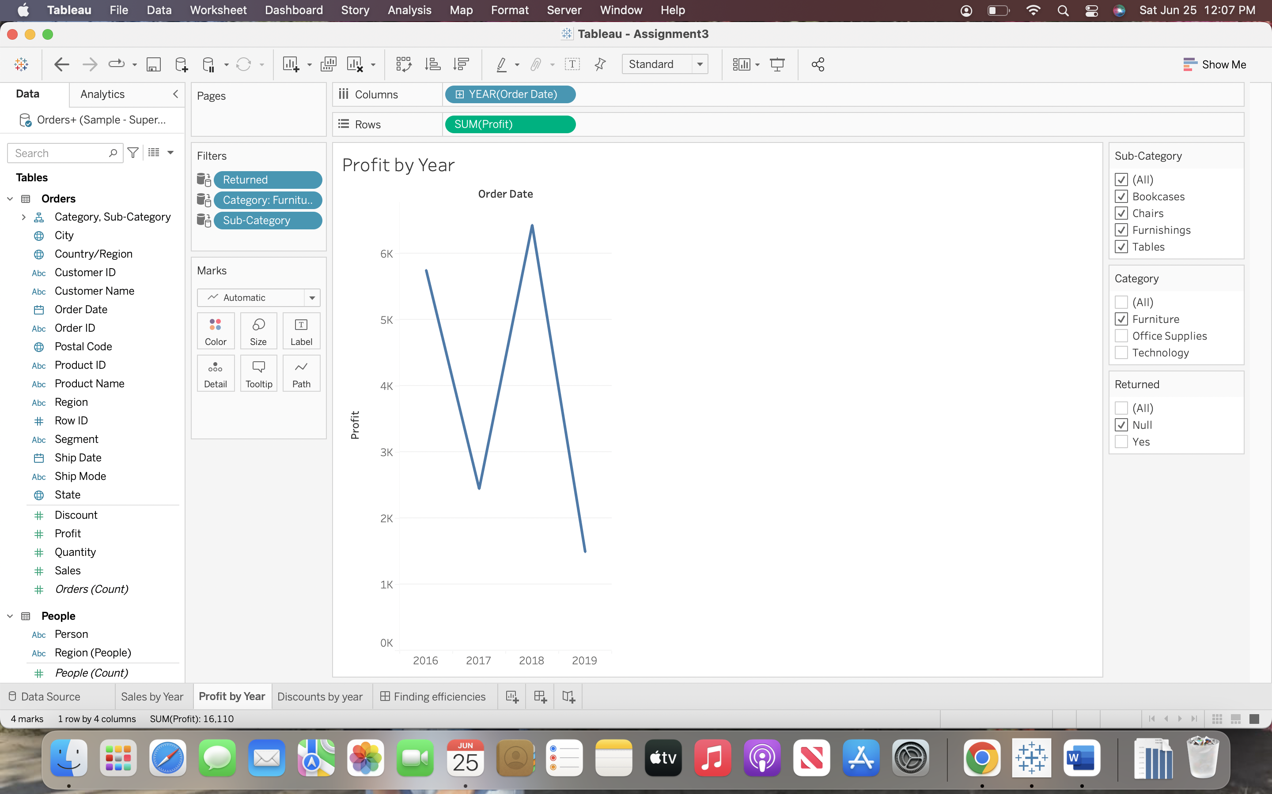

**Summary:**

If the discount percentage is reduced on the above-mentioned products, we can see some improvement on profits.